What is web ?

The Web is **a computer system that links documents and pictures into a database that is stored in computers in many different parts of the world and that people everywhere can use**.

ওয়েব হল একটি কম্পিউটার সিস্টেম যা নথি এবং ছবিগুলিকে একটি ডাটাবেসের সাথে লিঙ্ক করে যা বিশ্বের বিভিন্ন অংশে কম্পিউটারে সংরক্ষিত থাকে এবং যেটি সর্বত্র মানুষ ব্যবহার করতে পারে।

What is web server ?

A web server is a specialized type of computer system that delivers web pages and other content to users over the internet.

When you request a web page by typing a URL into your browser, your browser sends a request to the web server that hosts that page. The web server then processes the request, retrieves the requested content (such as HTML, CSS, images, or videos), and sends it back to your browser for display.

একটি ওয়েব সার্ভার হল একটি বিশেষ ধরনের কম্পিউটার সিস্টেম যা ইন্টারনেটের মাধ্যমে ব্যবহারকারীদের কাছে ওয়েব পেজ এবং অন্যান্য সামগ্রী সরবরাহ করে।

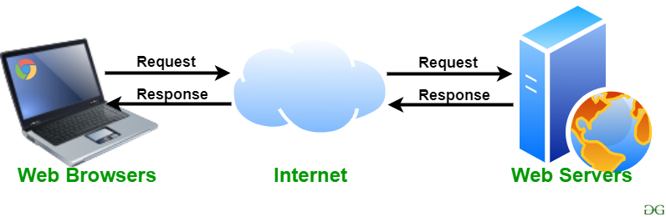

How does a web app work?

**1. User Interaction**

* **Client-Side**: The user interacts with the web app through a web browser on their device. This involves sending requests by clicking buttons, filling out forms, or performing other actions.

**2. Request Handling**

* **Client-Side**: The browser sends an HTTP request to the web server. This request might be for a specific page or to perform an action like submitting a form.
* **Server-Side**: The web server receives the request. Depending on the web app's design, it may directly serve static content (like HTML, CSS, and JavaScript files) or pass the request to an application server.

**3. Server-Side Processing**

* **Application Server**: The application server processes the request. This involves running server-side code written in languages like Python, Ruby, PHP, Java, or JavaScript (Node.js). The server-side code may interact with a database or perform other logic to handle the request.
* **Database Interaction**: If needed, the application server communicates with a database to retrieve, store, or modify data. This is common in web apps that involve user accounts, content management, or other dynamic data.

**4. Response Generation**

* **Server-Side**: Once the application server has processed the request and possibly interacted with a database, it generates a response. This response is typically in the form of HTML, JSON, or XML.

**5. Response Delivery**

* **Client-Side**: The web server sends the response back to the web browser. For web apps, this often involves delivering HTML content, CSS for styling, and JavaScript for interactivity.

**6. Rendering and Interaction**

* **Client-Side**: The browser renders the HTML, applies CSS for styling, and executes JavaScript to provide interactive features. JavaScript can also handle asynchronous operations (e.g., using AJAX or Fetch API) to update parts of the web app without reloading the entire page.

**7. User Feedback**

* The user sees the updated content or interface and can continue interacting with the web app. This process of sending requests and receiving responses continues as the user interacts with the app.

**Summary**

* **Front-End**: This is the part of the web app that runs in the browser, including HTML, CSS, and JavaScript.
* **Back-End**: This is the server-side part, which handles business logic, database interactions, and request processing.
* **Database**: Stores persistent data and interacts with the back-end to retrieve or save information.

Web apps are designed to be dynamic and interactive, allowing for rich user experiences and real-time updates.

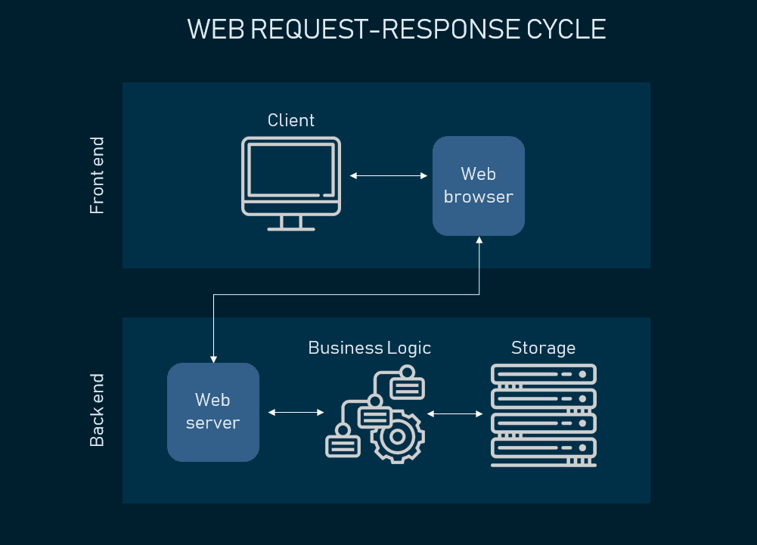

**How does internet works ?**

**The web browser connects to the web server and sends an HTTP request (via the protocol stack) for the desired web page**.

The web server receives the request and checks for the desired page. If the page exists, the web server sends it. If the server cannot find the requested page, it will send an HTTP 404 error message.

Difference between frontend and backend

